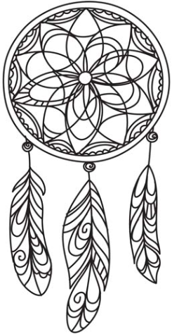
Native America and
Pocahontas

1 point..  Do some research about the Native Americans. Write what you find out. | 2 points…  Colour or design a dream catcher. We will be learning about them in class so you can wait until then. | 3 points…  Bring in some autumn leaves! Have a look for signs of trees that are losing their leaves and bring some in.
4 points..  Learn all the numbers that add up to 10. | 5 points…  Learn how to spell the numbers to 10. | 6 points..  Write a short story about Pocahontas. Bring it in and show us.
Everyday things to do.. Read your reading book. | Count forward and back to 20. | Practice your spellings
Collect points for having a go at these challenges at home over this half term! Ask someone at home to tick if you have completed any of the tasks or bring them in to show us in school because we would love to see what you have done. HAVE FUN!

